**Title: Ingredients Generation from Food Image**

**Goal:** Develop a system that can generate a title and ingredients based on the food image.

**Model:** Transformer. [ResNet-18 or 50 for feature extraction]

**Dataset:** Recipes 5k.

**Flow Diagram:**

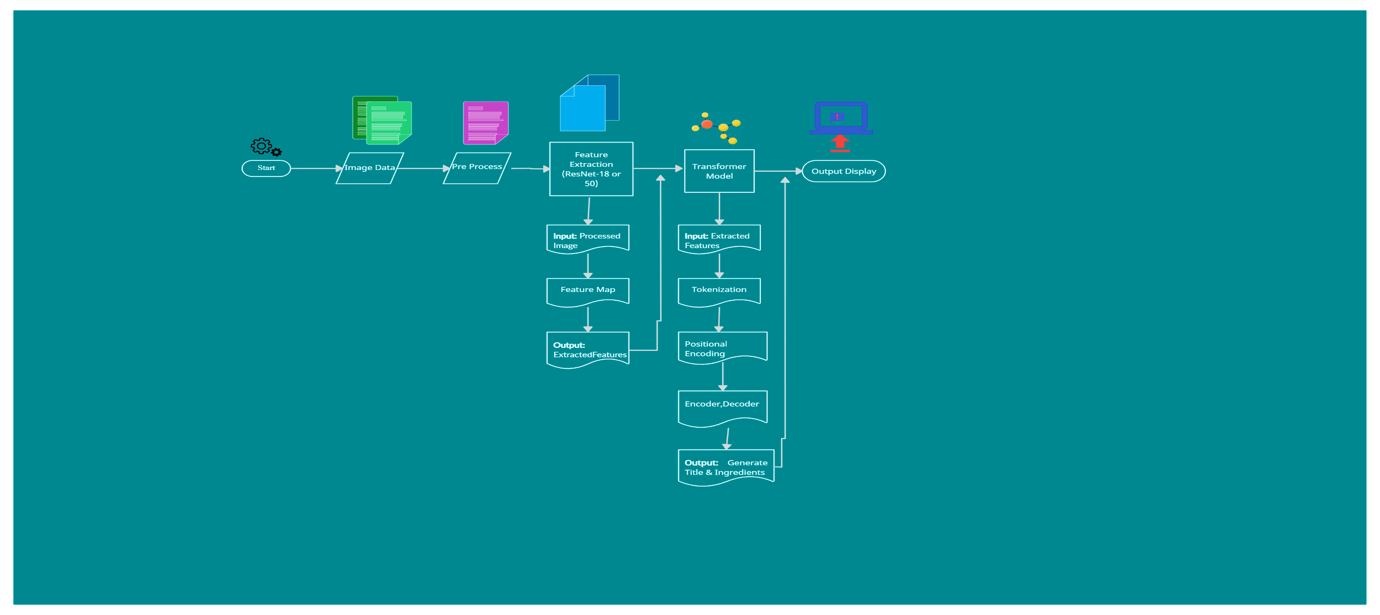

**Submitted by:**

**Jannatul Ferdous Jannah Mansura Mokbul**

ID: 200103020003 ID: 200103020028

10th Semester

Department of CSE

North East University Bangladesh.